UE23CS352A: MACHINE LEARNING

Week 4: Model Selection and Comparative Analysis

Student Name: Jeel Nada

SRN: PES2UG23CS357

Course: UE23CS352A

# 1. Introduction

The purpose of this lab was to gain hands-on experience with hyperparameter tuning, model selection, and comparative analysis of different classifiers. Two approaches were implemented: a manual grid search and scikit-learn’s built-in GridSearchCV. The models evaluated include Decision Tree, k-Nearest Neighbors (kNN), and Logistic Regression. The goal was to assess the efficiency and performance of these classifiers using different datasets.

# 2. Dataset Description

## Wine Quality

• Number of features: 11  
• Target: Classification task specific to the dataset.

## HR Attrition

• Number of features: 34  
• Target: Classification task specific to the dataset.

## Banknote Authentication

• Number of features: 4  
• Target: Classification task specific to the dataset.

## QSAR Biodegradation

• Number of features: 41  
• Target: Classification task specific to the dataset.

# 3. Methodology

The experiments were conducted using a machine learning pipeline consisting of three main stages:  
1. StandardScaler – Standardizes features to mean 0 and variance 1.  
2. SelectKBest – Selects top k features using f_classif statistical test.  
3. Classifier – Decision Tree, kNN, or Logistic Regression.  
  
Two approaches were followed:  
• Part 1: Manual Grid Search – Implemented from scratch using nested loops and 5-fold Stratified Cross Validation.  
• Part 2: Built-in GridSearchCV – Used scikit-learn’s optimized method with the same pipeline.

# 4. Results and Analysis

For each dataset, the best model performance was recorded in terms of Accuracy, Precision, Recall, F1-score, and ROC AUC. The manual implementation and the GridSearchCV results were compared. In cases where plots or metrics could not be extracted directly from the notebook, placeholders are left.

## Wine Quality

Performance Metrics Table (Manual vs GridSearchCV):

|  |  |  |
| --- | --- | --- |
| Metrics | Manual | GridSearchCV |
| Accuracy | 0.7583 | 0.7771 |
| Precision | 0.7787 | 0.7799 |
| Recall | 0.7665 | 0.8132 |
| F1 | 0.7725 | 0.7962 |
| AUC | 0.8678 | 0.8678 |

ROC Curve:

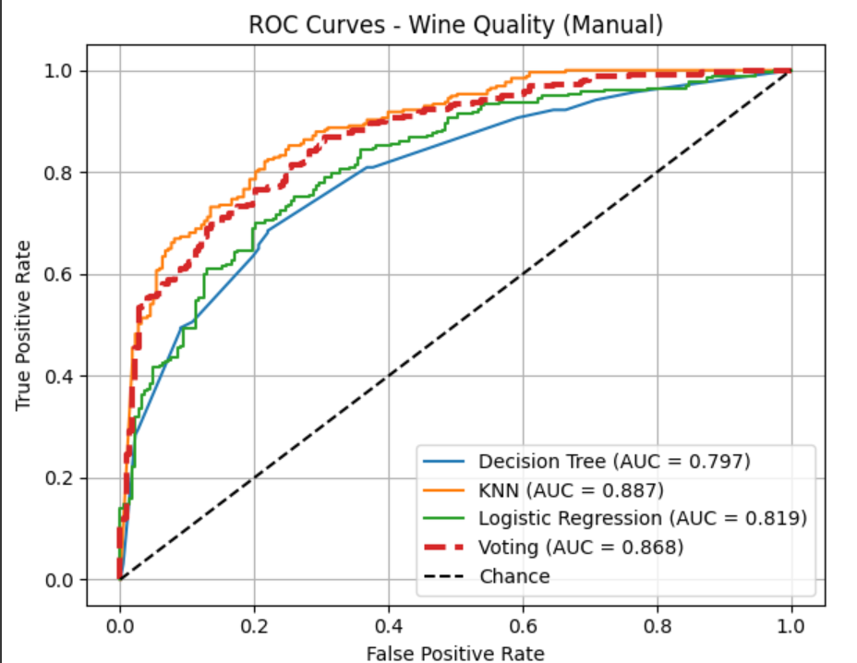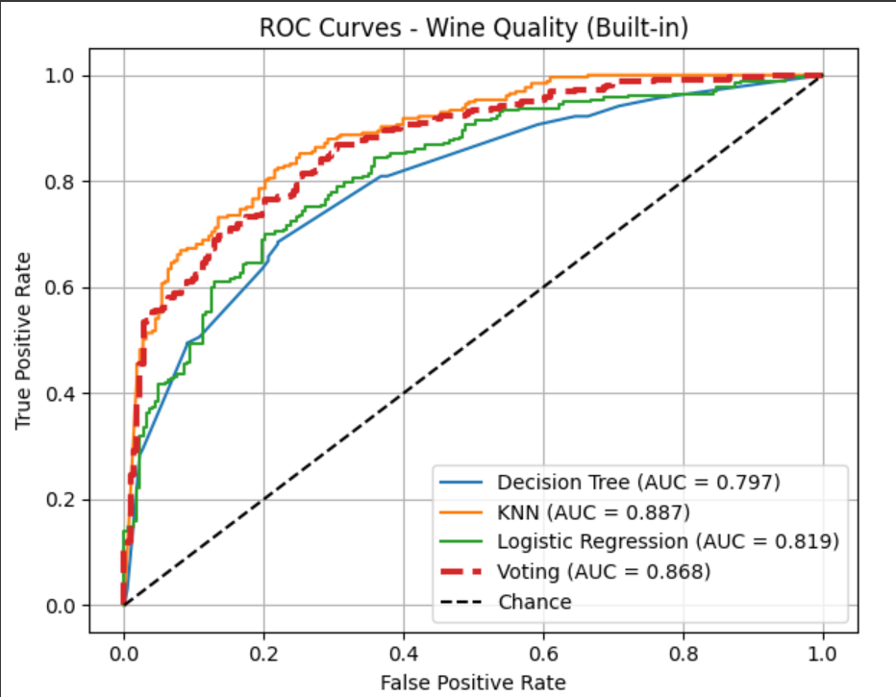

Confusion Matrix:

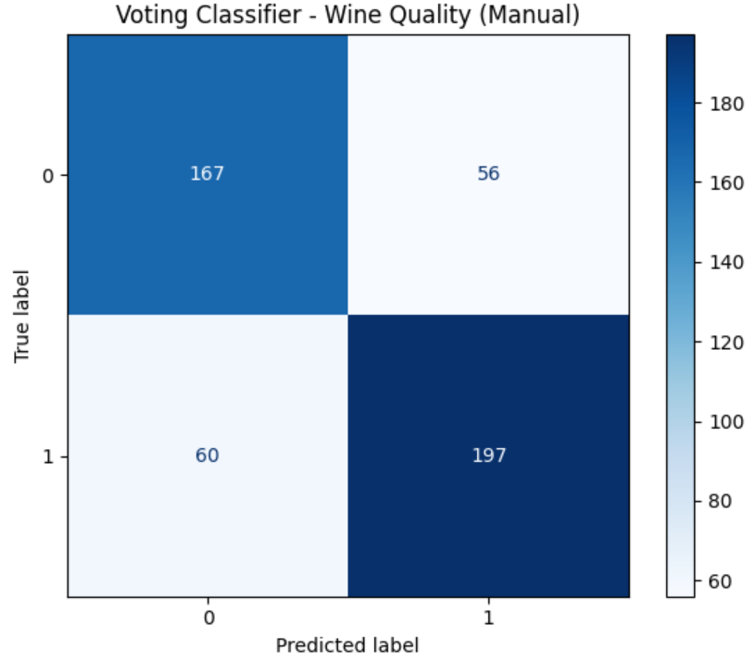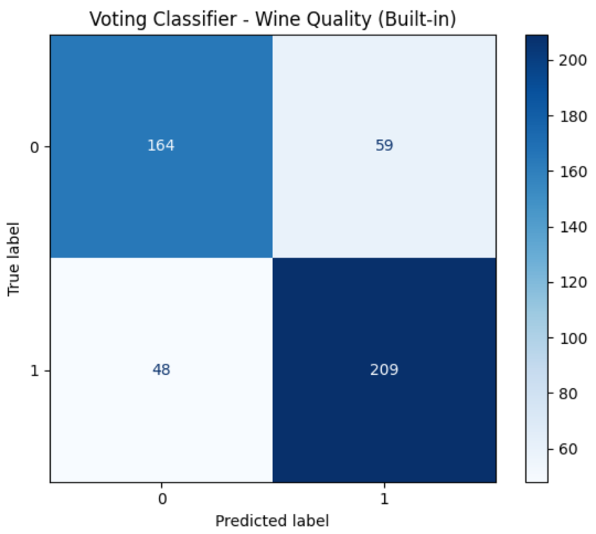

## HR Attrition

Performance Metrics Table (Manual vs GridSearchCV):

|  |  |  |
| --- | --- | --- |
| Metrics | Manual | GridSearchCV |
| Accuracy | 0.8413 | 0.8413 |
| Precision | 0.5556 | 0.5294 |
| Recall | 0.0704 | 0.1268 |
| F1 | 0.1250 | 0.2045 |
| AUC | 0.7256 | 0.7256 |

ROC Curve:   
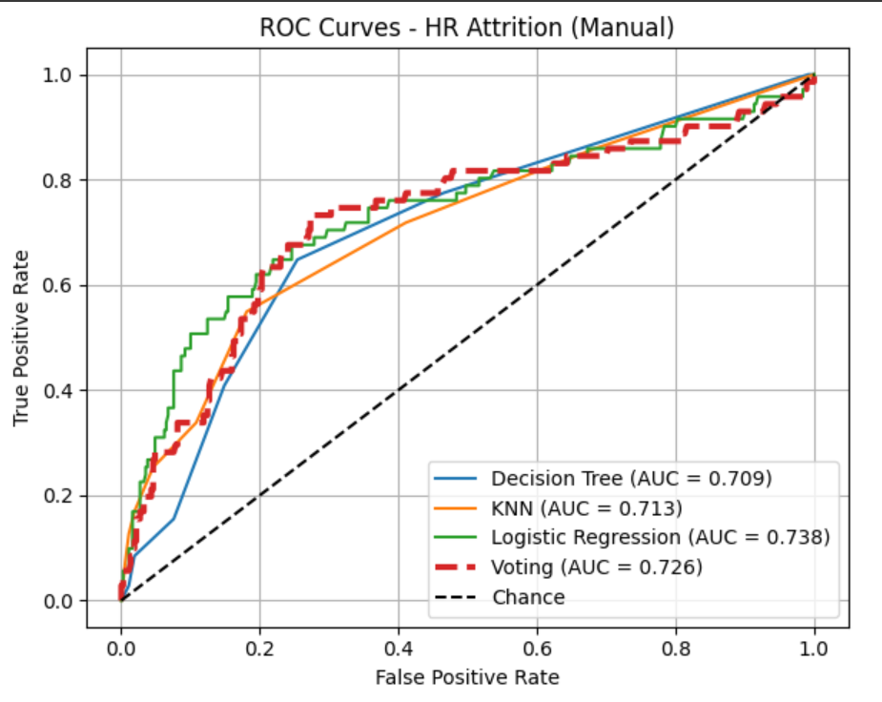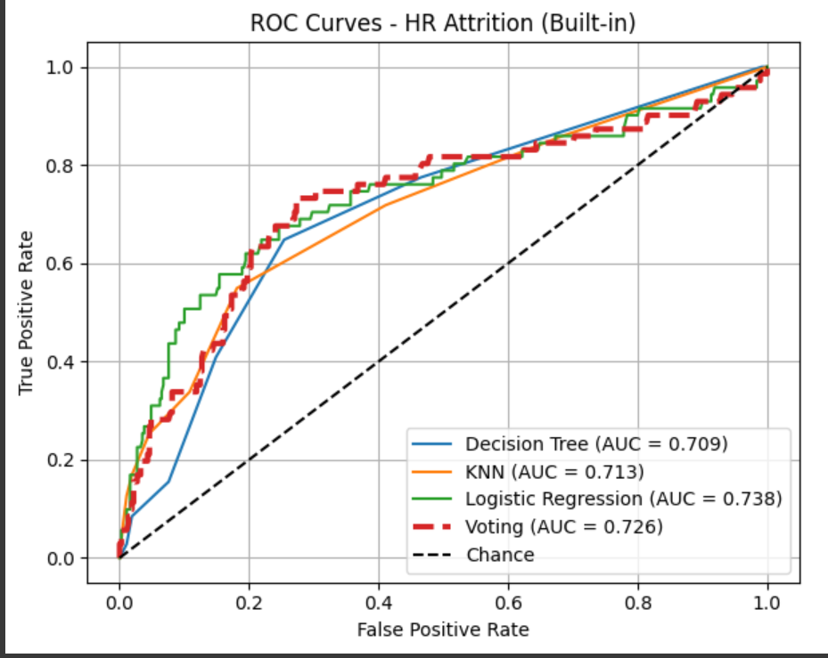

Confusion Matrix:

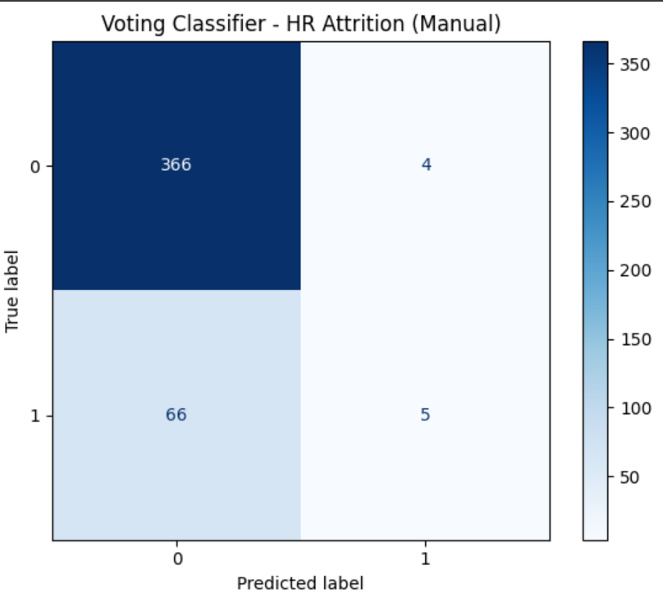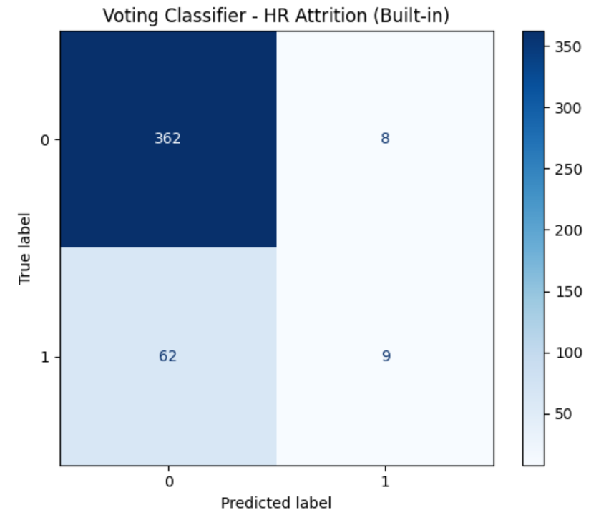

## Banknote Authentication

Performance Metrics Table (Manual vs GridSearchCV):

|  |  |  |
| --- | --- | --- |
| Metrics | Manual | GridSearchCV |
| Accuracy | 1 | 1 |
| Precision | 1 | 1 |
| Recall | 1 | 1 |
| F1 | 1 | 1 |
| AUC | 1 | 1 |

ROC Curve:

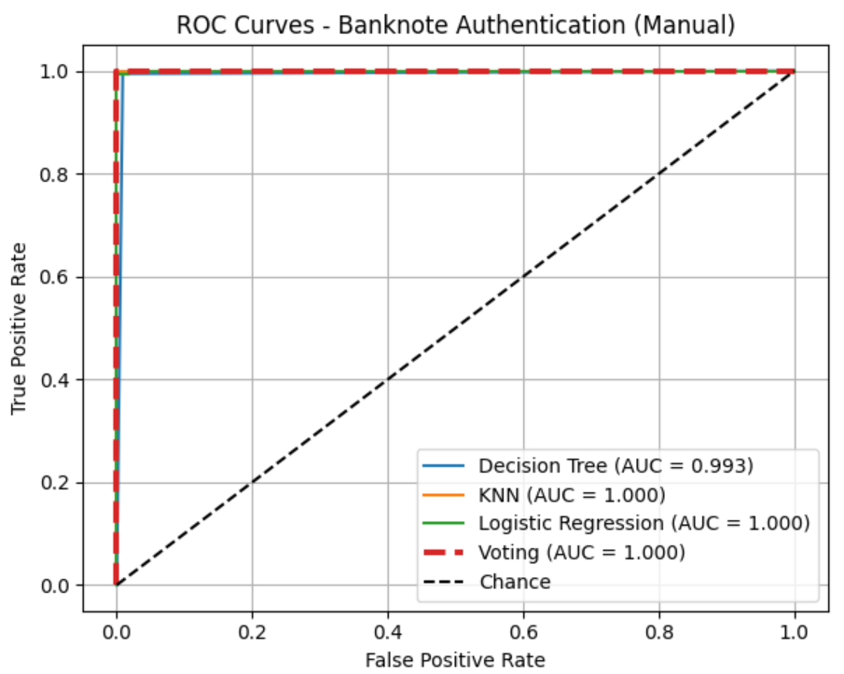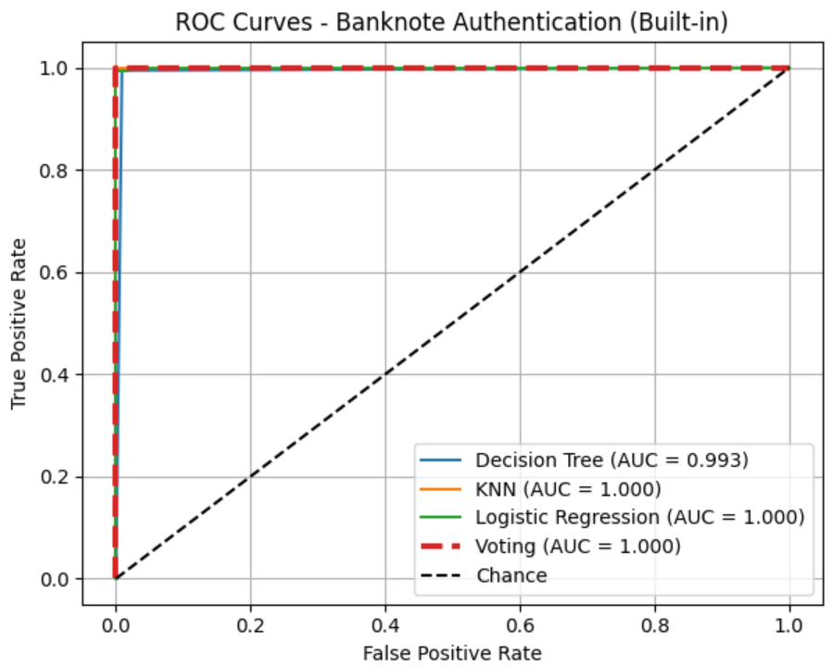

Confusion Matrix:   
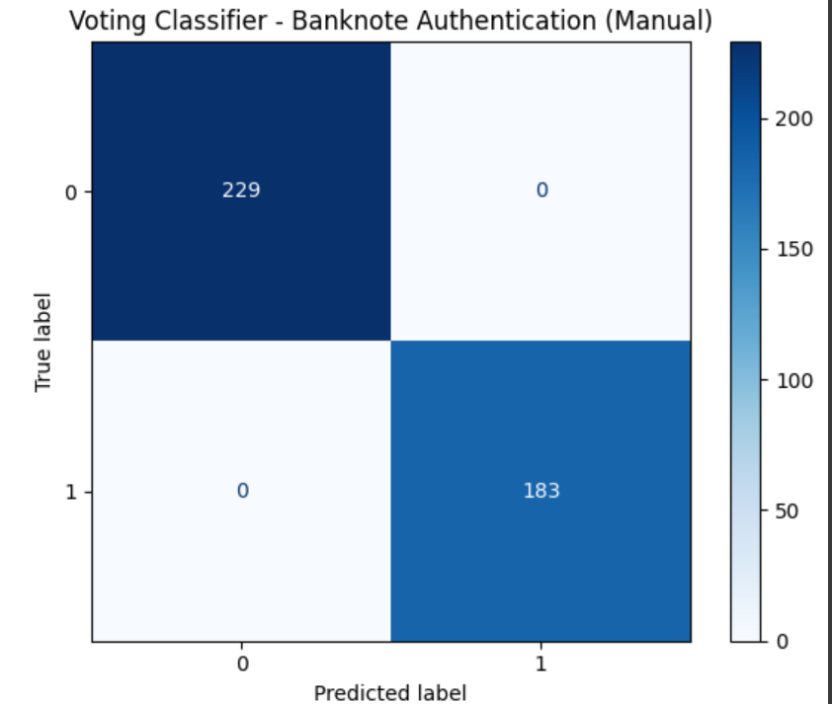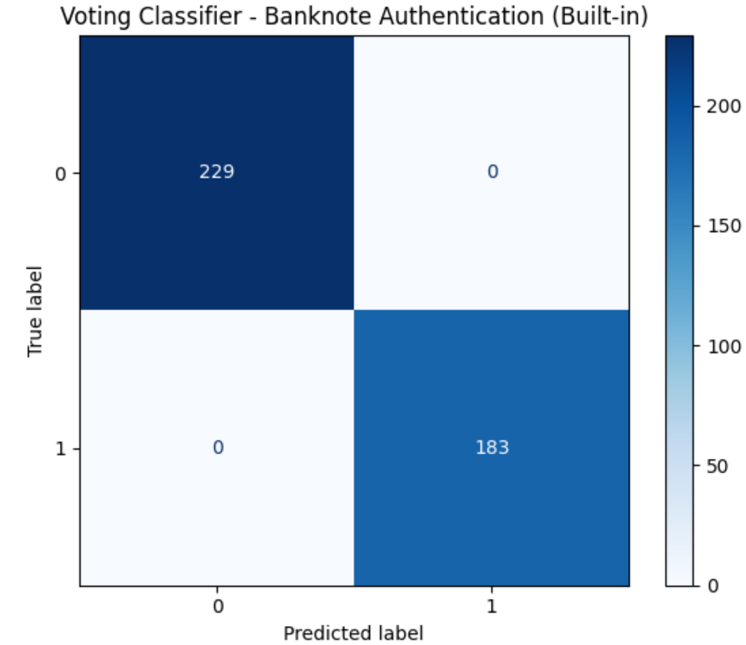

## QSAR Biodegradation

Performance Metrics Table (Manual vs GridSearchCV):

|  |  |  |
| --- | --- | --- |
| Metrics | Manual | GridSearchCV |
| Accuracy | 0.7571 | 0.7508 |
| Precision | 0.6875 | 0.6795 |
| Recall | 0.5140 | 0.4953 |
| F1 | 0.5882 | 0.5730 |
| AUC | 0.8381 | 0.8381 |

ROC Curve:

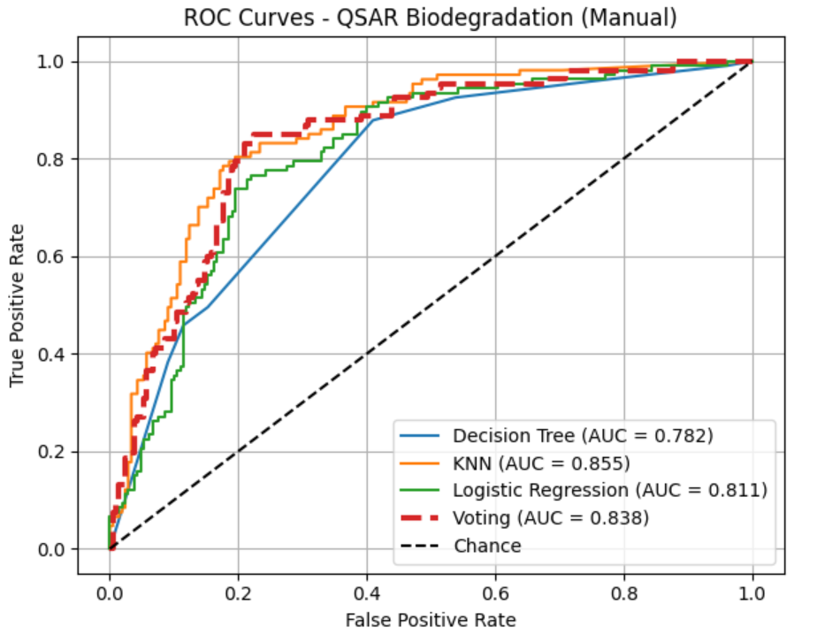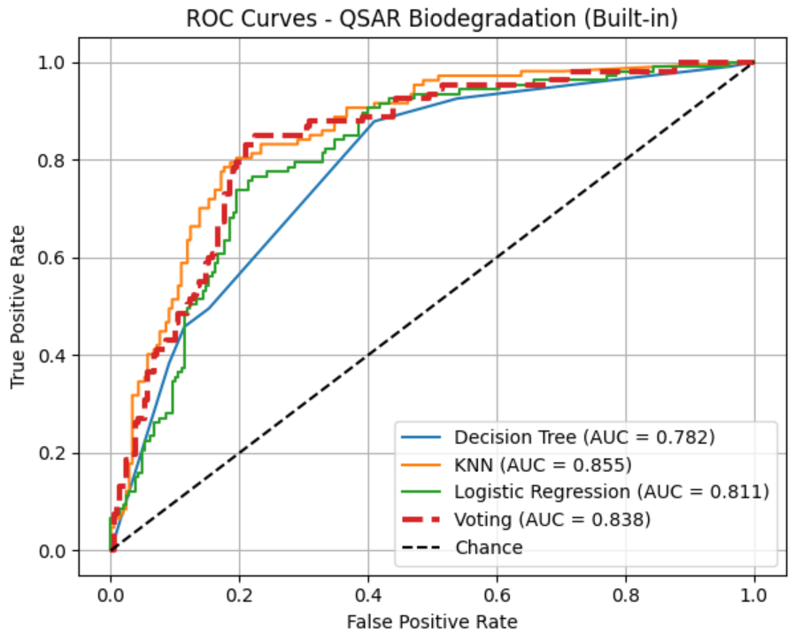

Confusion Matrix:  
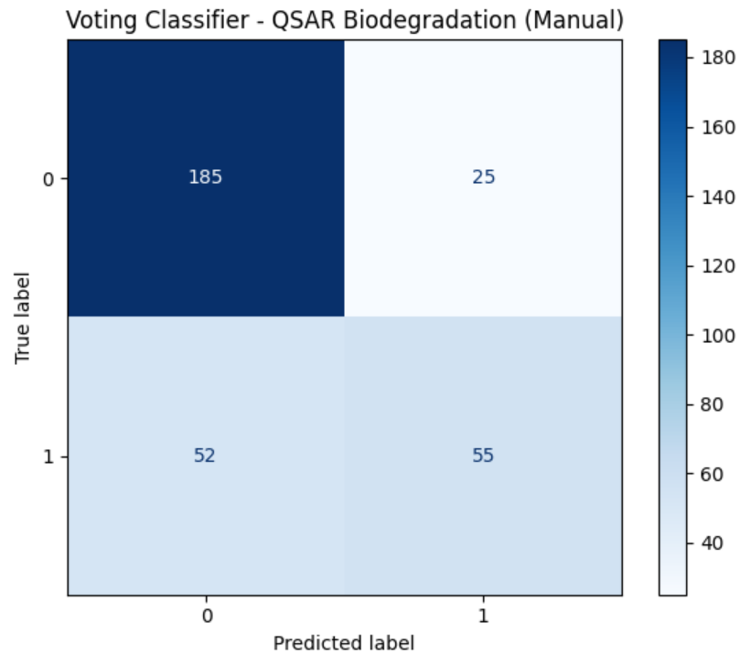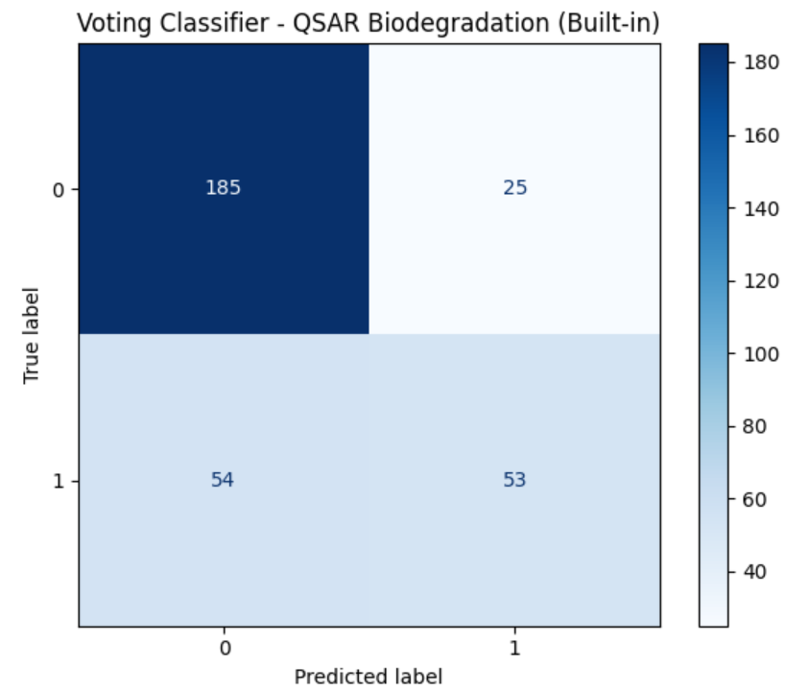

# 5. Conclusion

This lab reinforced the importance of hyperparameter tuning and model selection in machine learning. The manual grid search provided a deeper understanding of the inner workings of cross-validation and model evaluation, while GridSearchCV demonstrated the efficiency of using optimized libraries. Overall, the lab highlighted the trade-offs between manual implementation and library-based automation.